# Sprint 2 Plan - Scrum Tools

## Revision 1 - 2/17/2024

## Sprint Completion - 2/24/2024

# Goal

In this sprint, we want to get the page to create release plans done, and the page to view and edit release plans done. The release plan editing page will only include things like text, but not things that deal with user stories such as the backlog and sprints.

# Spikes/Infrastructure

Learn TypeORM, and replace the existing Mongoose with it.

# Task Listing

### Story 1

| **Priority** | **Story** | **Acceptance Criteria** | **SP** |
| --- | --- | --- | --- |
| 1 - Must | As a product owner, I want to create new release plans so I can add to previous plans and communicate my plan to the team. | Have a good form for inputting and editing a release plan  Be able to create a new release plan based on the current release plan  Changes can be saved.  Have automatically generated version numbers depending on if a release plan is created fresh, or if it is a revision of a previous release plan.  Team can see all versions (previous versions, signed versions, unsigned versions) of the release plan. | 5 |

| **Tasks** | **Ideal Hours** |
| --- | --- |
| 1. ~~Design a page to view release plans~~ | ~~4~~ |
| 1. Implement the design into the app | 3 |
| 1. ~~Implement the Project, Release Plan, Sprint Plan entities for TypeORM~~ | ~~2~~ |
| 1. ~~Create new backend functions to make a copy of a release plan~~ | ~~1~~ |
| 1. ~~Create new backend functions to save release plans~~ | ~~1~~ |
| 1. Opening a release plan loads it into the editor | 2 |
| 1. ~~Create new backend functions to get previous release plans’ versions~~ | ~~3~~ |

# Initial Task Assignment

| **Team member** | **Initial Task** |
| --- | --- |
| Edison | 1.1 |
| Tanya | 1.1 |
| Arthur | 1.5 |
| Andrew | 1.3 |
| Michael | 1.4 |

# Initial Burnup Chart

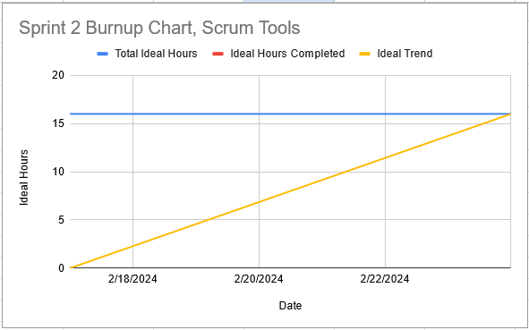

# Initial Scrum Board

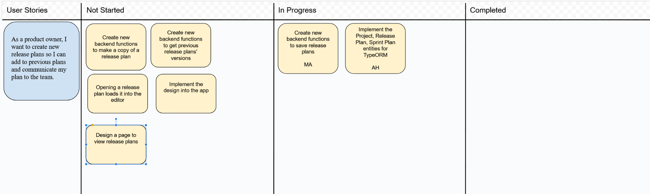

# Team Roles

| **Team member** | **Role(s)** |
| --- | --- |
| Edison | Frontend |
| Tanya | Frontend |
| Arthur | Front/Backend |
| Andrew | Backend |
| Michael | Backend |

# Scrum Times

Monday 1:15-2:00 pm (TA meeting)

Wednesday 1:15 pm

Saturday 1:15 pm